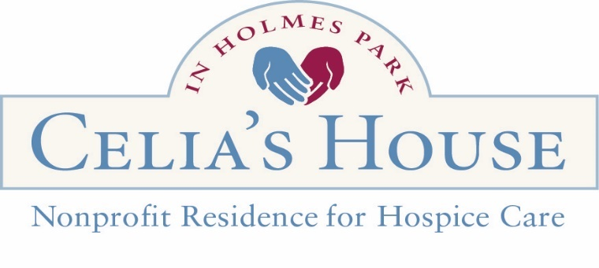

Dear Prospective Volunteer,

We want to thank you for wanting to become a volunteer at Celia’s House. We look forward to adding your unique skills to our community.

Who are Southern Oregon Friends of Hospice and Celia’s House?
Southern Oregon Friends of Hospice is a 501(c)(3) non-profit organization operating Celia’s House., Here, we offer a welcome option for hospice care when dying at home is not an option. Visit www.celiashousehospice.org.

Hospice is defined as care for terminally ill patients when the priority is not to provide further treatment but to reduce pain and discomfort toward the end of life. It is meant for patients not expected to live more than six months.

Volunteer Opportunities
The following are descriptions of the most common volunteer positions, but everyone has unique skills, so if you have another talent to share, please list it on the application.

- Resident Support Volunteer (RSV): RSVs (Resident Support Volunteers) are trained to support the mental and emotional well-being of residents and their loved ones at the bedside. (See separate application below).

- Front Desk Greeter Volunteer* - Set a welcoming tone & help check in visitors.

- Kitchen Volunteer * Kitchen volunteers support the kitchen. They also bring meals to our residents and help clean up the kitchen afterward.

- Music Volunteer* – Play music at the house for resident and family enjoyment and enrichment.

- Garden Volunteer: Help maintain our beautiful gardens. No experience required!

- Office Volunteers: Filing, scanning, and administrative work.

Thank you again for your interest in volunteering with Southern Oregon Friends of Hospice. You are welcome to keep this first page for your records. To get started, please complete the attached application, and return a digital scan or mail the completed form. We will happily answer any questions via phone or e-mail.

Sincerely,
Brieann Belanger
Brieann.belanger@sofriendsofhospice.org
541-500-8911 Ext. 312
541-690-0221 cell
217 S. Modoc Ave
Medford, OR 97504

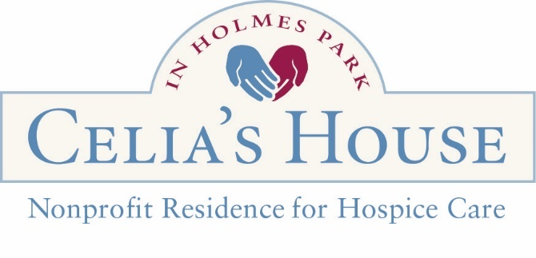
Celia’s House Volunteer Application

Today’s Date: __________________

Full Name: ____________________________________________________________

Birthdate (mm/dd/yyyy): ________________

Email: ________________________________________________________________

Address: _______________________________ City ________________ Zip _______

Phone: _______________________________ Cell: ____________________________

Emergency Contact Information
Name:_______________________________Relationship: _____________________
Phone Number: ______________________________________________________

Celia’s House Volunteer Opportunities
- Resident Support Volunteer
(Additional Form and Training Required)
- Front Desk Volunteer
- Spiritual Care Volunteer (Inclusive Support for Diverse Beliefs; Includes Chaplain Interview, Training Required)
- Garden Volunteer
- Kitchen Volunteer
- Music Volunteer (type) _______________
- Event Volunteer____________________
- Office Assistance (related skills) ________ ____________________________________
- Other (please specify) _______________

Days/Hours Available:
Monday __________ Tuesday __________ Wednesday __________
Thursday _________ Friday _________ Saturday __________ Sunday _________

Please answer the following questions to the best of your ability.

Why do you want to be a volunteer at Celia’s House?
____________________________________________________________________________________________________________________________________________
What is your professional background, and are you interested in applying these specific skills and talents as a volunteer role? [] Yes [] No
(Associated skills and talents) _____________________________________________
_____________________________________________________________________

What other languages do you speak fluently? _________________________________________________

How did you learn about Celia’s House? _____________________________________
Allergies or medical conditions you would like us to be aware of:
____________________________________________________________________________

Do you have any health or physical limitations we need to consider in assigning you to volunteer tasks?

Do you have any previous experience or training in providing end-of-life care, grief support, or related areas? [] Yes [] No
(If yes, please describe.) __________________________________________________

Have you ever volunteered in a hospice or similar setting before? [] Yes [] No
(If yes, please provide details.) ____________________________________________

Signature: ______________________________________ Date: _________________

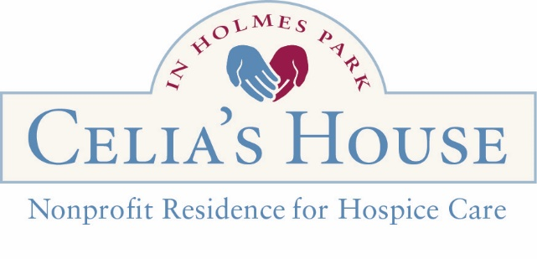
Background Check Form - REQUIRED
Please print neatly. Thank you!

Full Legal Name: _______________________________________________________________________________

Previous Names/Aliases: ____________________________________________________________________

Date of Birth: ______________________________

Driver’s License or State ID Number: ___________________________________

State that issued ID: ___________________

Email Address: ________________________________________________________________
(A valid email address is needed to complete the background check, and you will receive an email from OARCHARDS. if you do not have an email or are unwilling to complete the form digitally, please contact the QED for a complete paper background check form)

Current Address: ___________________________________________________________________________________

Phone Number: ___________________________________________________

Social Security Number (Optional): __________________________

Other Addresses in the last five years and specific years (e.g. 2019-2023) of residence: ________________________________________________________________________________________________________________________________________________________________________________________________________________________________________________________________________________________________________________________________________________________________________________________________________________________________
Gender:

□ Male □ Female
□ Non-Binary
□ Prefer not to say

FOR OFFICE USE
Picture ID checked by: _________________________
Date of Submitted Background Check: _____________
Date of Approved Background Check: _____________

Background Check Form - REQUIRED

Race:
□ American Indian or Alaska Native - a person having origins in any of the original peoples of North or South America (including Central America), and who supports tribal affiliation or community attachment.
□ Asian - a person originating in any of the original peoples of East Asia, Southeast Asia, or the Indian subcontinent, including Cambodia, China, India, Japan, Korea, Malaysia, Pakistan, the Philippine Islands, Thailand, or Vietnam.
□ Black or African American - origins in any of the Black racial groups of Africa.
□ Native Hawaiian or Other Pacific Islander - a person having origins in any of the original peoples of Hawaii, Guam, Samoa, or other Pacific islands.
□ White - a person having origins in any of the original peoples of Europe, the Middle East, or North Africa.
□ Prefer not to say

Ethnicity:
□ Hispanic or Latino/a - a person of Cuban, Mexican, Puerto Rican, South or Central American, or other Spanish culture or origin, regardless of race.
□ Not Hispanic or Latino/a
□ Prefer not to say

The role you plan to fill at the Celias House:
- Volunteer -Specific Role: _____________________
- Staff – Job Title: ___________________________
- Other ___________________________

If you have potentially disqualifying convictions or conditions, the BCU (Background Check Unit) must consider several factors to determine the risk of vulnerable individuals and your fitness to hold the position. Please provide any information about the details of your potentially disqualifying history, yourself, your training, education, work history, treatment, and circumstances since your potentially disqualifying history that you want the BCU to weigh. Add additional pages as needed. ________________________________________________________________________________________________________________________________________________________________________________________________________________________________________________________________________________________________________________________________________________________________________________________________________________________________
Background Check Form - REQUIRED

I understand that Celia’s House in Holmes Park is licensed as a Residential Care Facility by the Department of Human Services for Oregon; as such, people who work or volunteer with our residents must complete a background check. By signing, you affirm the following statements to be true.

- You have never been convicted of any form of abuse.

- If you do any form of professional work in the facility, you have all the proper licenses, certifications, and approvals to perform such tasks, or you will obtain all proper licenses, certifications, and approvals before performing such tasks. (i.e., food handlers license).

- You understand that completing this form will begin a background check process; failure to complete the background check process or pass the background check may limit your ability to work at Celia’s House in Holmes Park.

Signature: ________________________________________________ Date: ______________

REFERENCES - REQUIRED

Please list at least two people who know you well, one professionally and the other personally.
Name/Title: Relationship: phone or email address (required):
1.___________________________________________________________ 2.___________________________________________________________ 3.___________________________________________________________ 4.___________________________________________________________
I understand that Celia’s House of Southern Oregon Friends of Hospice, is a non-profit 501(c) 3. I allow Southern Oregon Friends of Hospice to contact my references and conduct a background check.
Signature: ____________________________________Date: ________
Thank you for completing your application to Celia’s House.

Issued: March 18, 2015
Reviewed: May 12, 2022 Reviewed by: Executive Director Revised:
Review Responsibility: Executive Director

1-3 Confidentiality

This is a confidentiality policy for Employees, Volunteers and Board Members. Respecting the privacy of our clients, donors, members, staff and volunteers and of Southern Oregon Friends of Hospice itself is a basic value of Southern Oregon Friends of Hospice.
Personal and financial information is confidential and should not be disclosed or discussed with anyone without permission or authorization from the executive director. Care shall also be taken to ensure that unauthorized individuals do not overhear any discussion of confidential information and that documents containing confidential information are not left in the open or inadvertently shared. Employees, volunteers and board members of Southern Oregon Friends of Hospice may be exposed to information which is confidential and/or privileged and proprietary in nature. It is the policy of Southern Oregon Friends of Hospice that such information must be kept confidential both during and after employment or volunteer service. Staff and volunteers, including board members, are expected to return materials containing privileged or confidential information at the time of separation from employment or expiration of service. Unauthorized disclosure of confidential or privileged information is a serious violation of this policy and will subject the person(s) who made the unauthorized disclosure to appropriate discipline, including removal/dismissal.
Certification
I have read Southern Oregon Friends of Hospice’s policy on confidentiality presented above. I agree to abide by the requirements of the policy and inform my supervisor immediately if I believe any violation (unintentional or otherwise) of the policy has occurred. I understand that violation of this policy will lead to disciplinary action, up to and including termination of my service with Southern Oregon Friends of Hospice.

Signature ________________________ Name ______________________ Date __________

